EXP- 5
MoSCoW – Library Management System
Aim
To categorize requirements using MoSCoW method.
Procedure
1. List all requirements.
2. Analyze impact & feasibility.
3. Categorize into:
●Must Have , Should Have
●Could Have
●Won’t Have
4. Enter into Excel/Google Sheet.
5. Add justification column
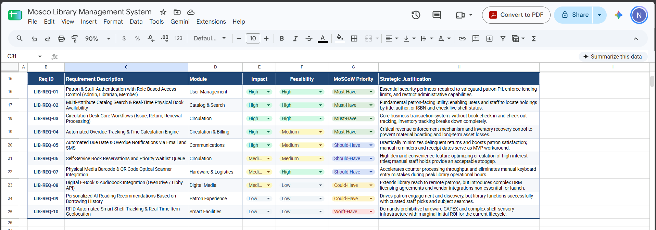
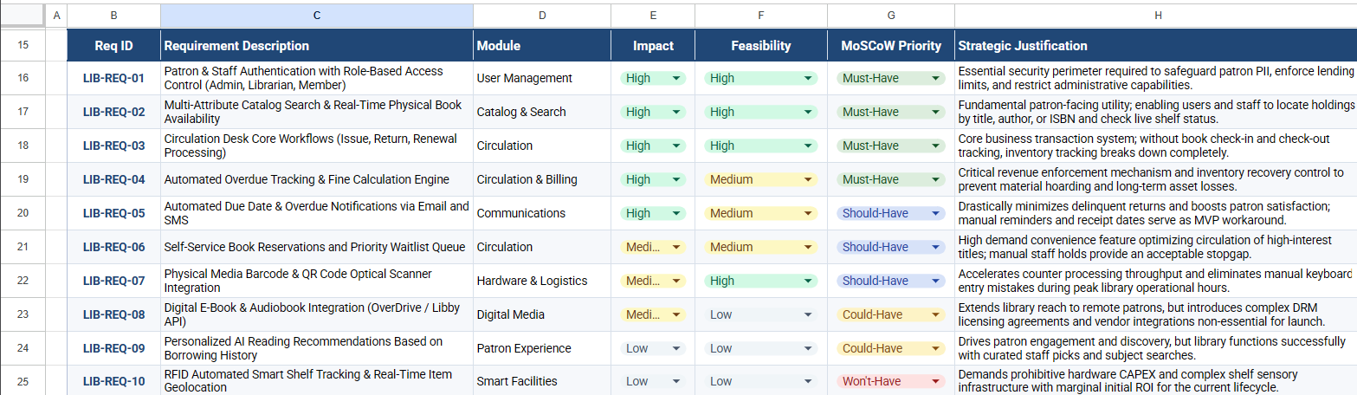

Result: Thus, The Requirements categorized successfully using MoSCoW prioritization

